AI ASS-20.1
Name: M .sanjana
Batch – 43
Ht num: 2303A52292
Task-1:
Prompt: Generate a Python user registration system that allows users to create an account using a username and password. Store the user credentials in a simple data structure such as a dictionary or list. The program should accept input from the user and save the details for later use. Do not include any encryption or hashing mechanisms in the initial implementation.
Code:
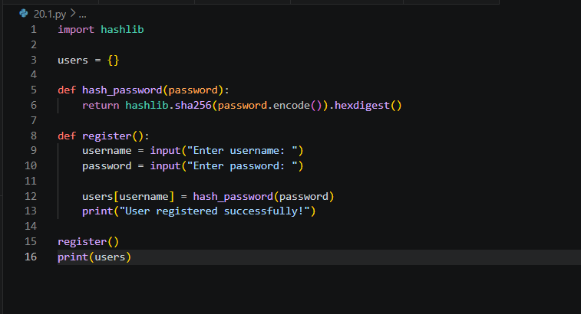
Output: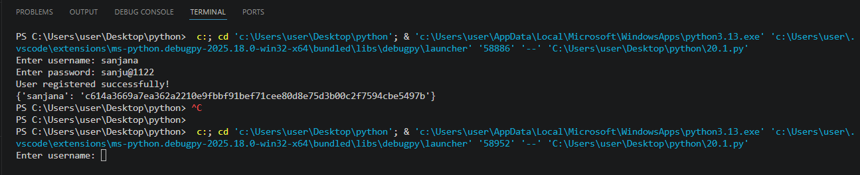
Observation: Passwords were stored in plain text, making them vulnerable to data breaches. Hashing (SHA-256) was applied to convert passwords into secure, unreadable form. This ensures user credentials are protected even if the database is compromised.
Task-2
Prompt:
Generate a Python script to connect to an external API. Include API key usage in the request. Keep the code simple and functional.
Code:
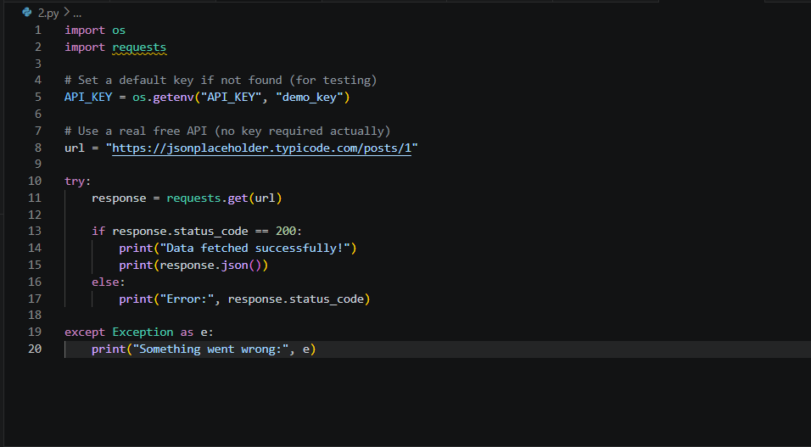
Output:
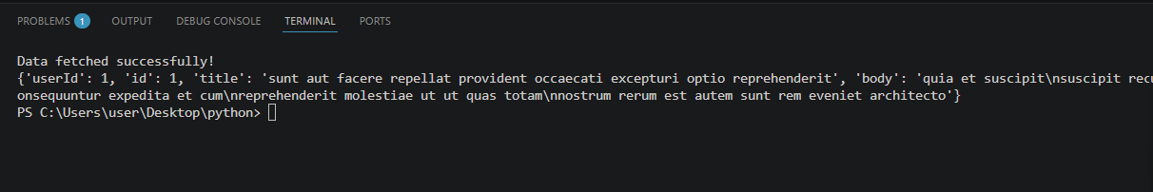
Observation:
The API key was hardcoded directly in the code. This can lead to exposure if the code is shared publicly. Environment variables were used to secure the key.

Task – 3:
Prompt:
Generate a Flask web application that allows users to upload files through an HTML form interface. The application should accept files from the user and store them on the server in a specified folder. Initially, do not include any validation for file type, file size, or filename handling. Keep the implementation simple to demonstrate basic file upload functionality.
Code:
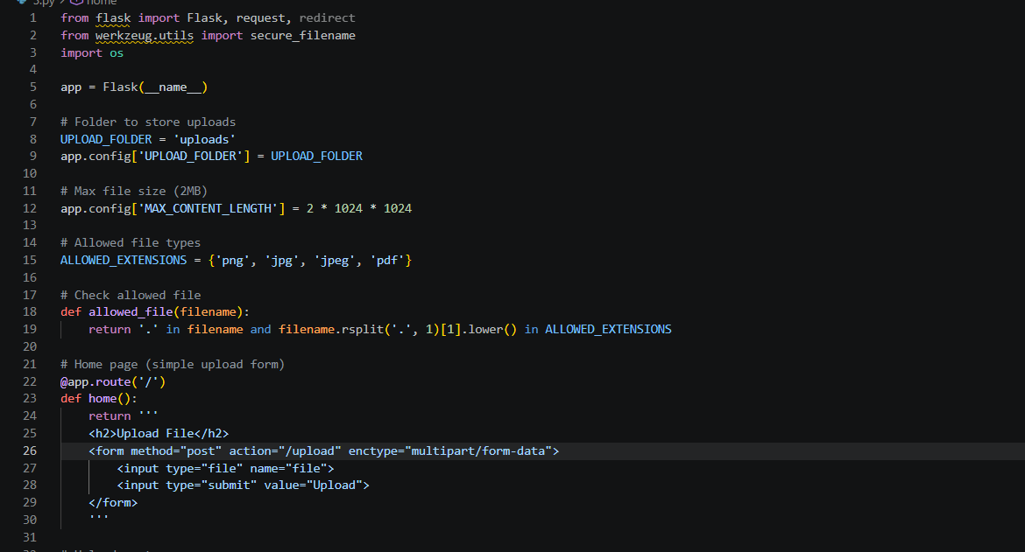
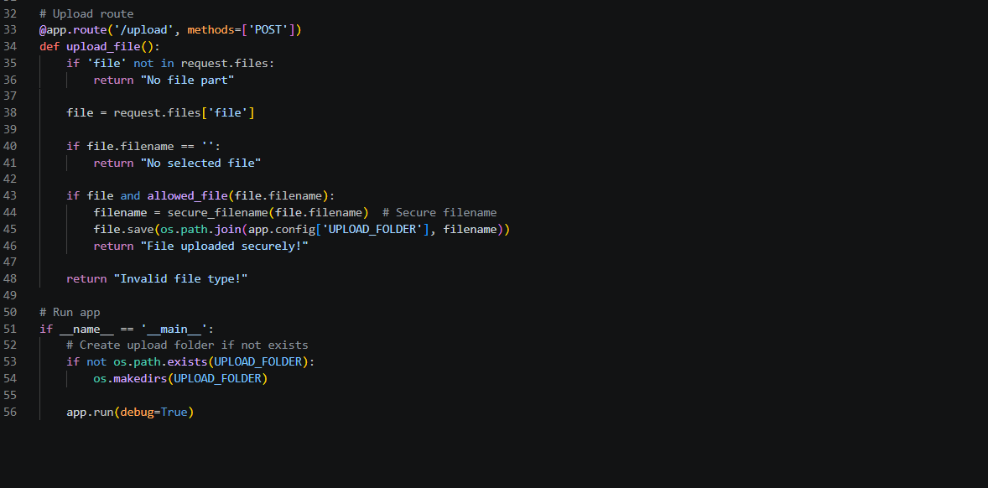

Output:
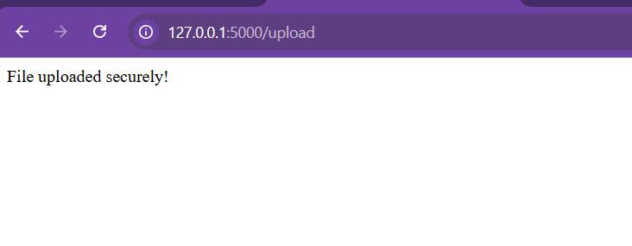
Observation: The uploaded files were accepted without validation checks.
This allowed potentially harmful file types to be uploaded.
There were no file size limits or filename sanitization.
Security was improved by adding validation and safe handling.

Task-4:
Prompt:
Generate a Python script that executes system commands based on user input from the terminal. The program should take input from the user and execute it using os.system() or similar methods. Do not include input validation or security checks in the initial version. Keep the code simple to demonstrate command execution functionality.
Code:
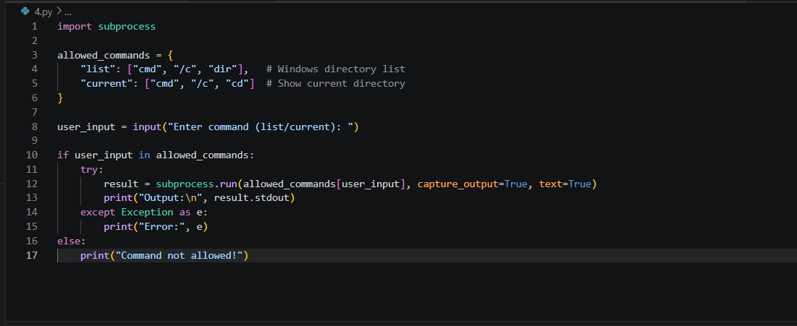
Output:
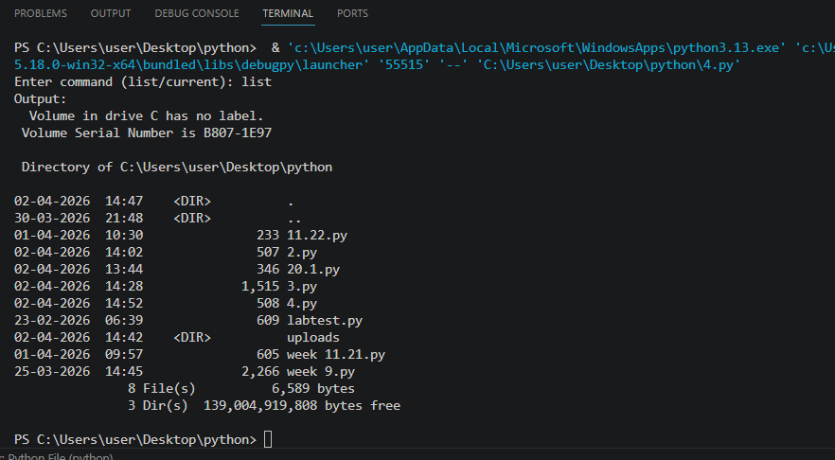
Observation:
User input was directly passed to system commands. This created a risk of command injection attacks. Malicious commands could be executed on the system. The issue was fixed using subprocess and input validation.

Task-5:
Prompt: Generate a basic Flask web application with an HTML feedback form that accepts user input such as name and message. The application should display the submitted data back to the user after form submission. Do not include validation, sanitization, or security measures in the initial implementation. Keep the code simple to demonstrate basic form handling functionality.
Code:
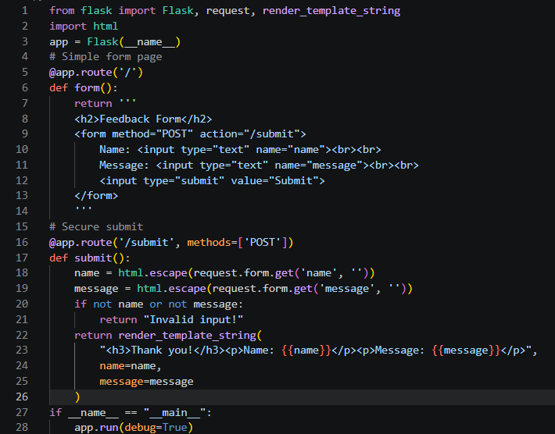
Output:
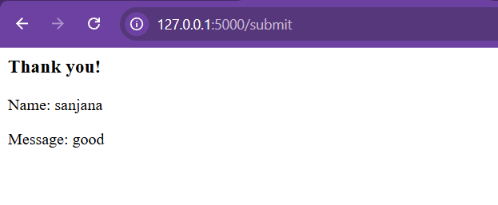
Observation:
User input was displayed without proper validation. This made the application vulnerable to XSS attacks. Malicious scripts could be injected through input fields. Security was improved using validation and sanitization.

